3/4/2021

Nadir Hussain

023-18-0025

Computer Networks

Lab 03

**Lab Objectives**

* **Create network of multiple hosts using eNSP switch.**
* **Understand the ARP protocol working mechanism**
* **Working with VRP(Versatile Routing platform) and its commands**
* **Connecting PCs located on different networks**

**Creating Network of multiple Hosts**

**Use switch to achieve the goal. We create single network of 3 hosts.**

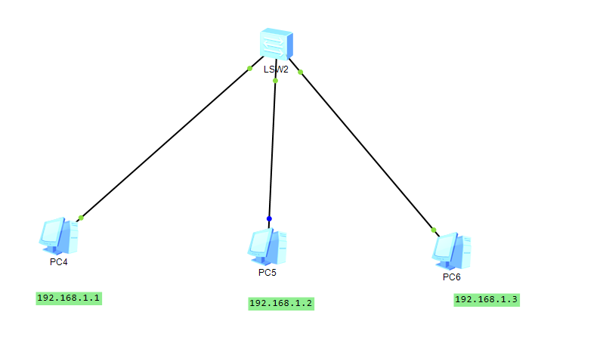

**Switch:**

Switch is network component that helps to connect multiple Pcs in same network. Switch ues STP(Spanning Tree protocol) to connect multiple devices, because minimum cost to connect all PCS is required and switch uses MST(Minimum cost spanning tree) algorithm to implement STP.

Make sure that first 3 octats for all hosts are same.

192.168.1 are first 3 octets which are same for all hosts.

Simultaneously the wireshark captures

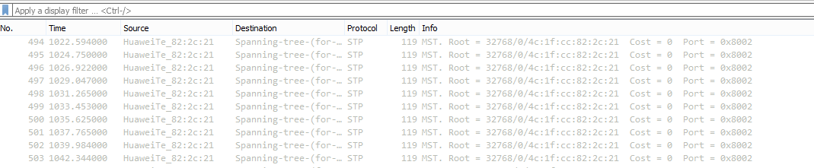

We see it shows STP protocol.

Now we ping from PC4 to PC5 and observe the network.

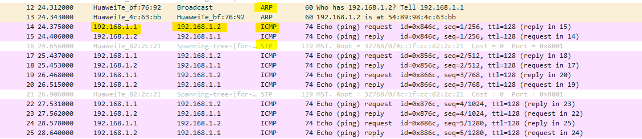

**ARP, STP and ICMP protocols are used.**

**ARP: Address resolution protocol**

**STP: Spanning tree protocol, find the closest switch**

**ICMP: Internet message control protocol: Used by ping protocol to transmit messages between nodes**

**Working with VRP**

VRP (Versatile routing platform)

Represents foundation of many Huwei products including routers and switches.

We can configure these products by the command line and VRP commands.

A separate console can be connected to switch or router to change the configuration.

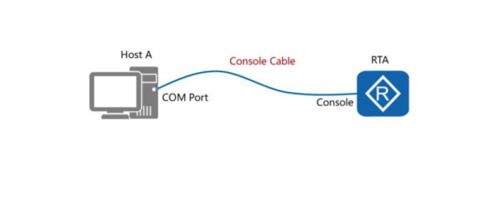

Or

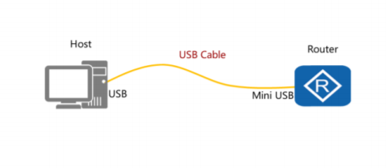

**VRP CLI Commands**

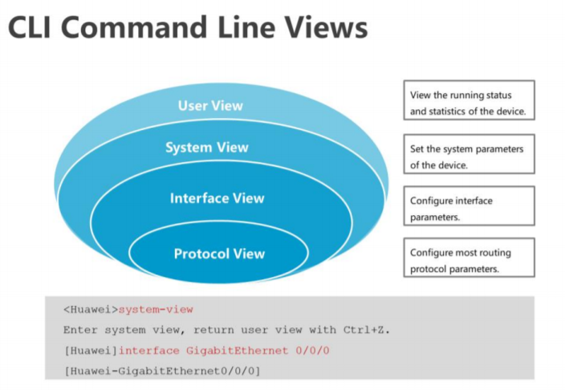

User view has least privileges and very less access to Huwei products is given at this view.

On System view, a bit more priviliges are given and we may change the device config, however we can’t change the protocol which can be changed in protocol view.

*By default the device to which VRP console is in user mode/view*

**VRP Commands**

**Changing view from user to system.**

system-view

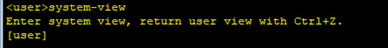

**Assign name to device**

Sysname Router_01

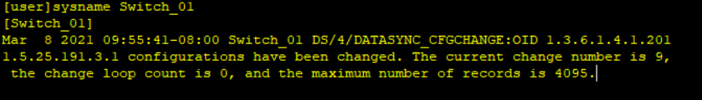

**Display current date time stamp**

Display clock

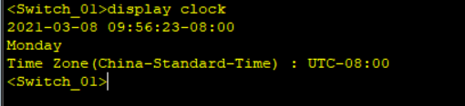

**Enabling teletyping on Huwei products**

User-interface vty 0 4

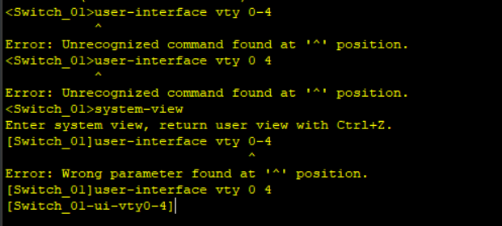

//0 4 means 5 users can configure the device remotely at same time

**Set the session/ connection time out for user**

Idle-timeout 1 30



//1 30 means 1 minute and 30 seconds

**Save number of commands in history**

History-command max-size 20



**Set CLI interface permissions**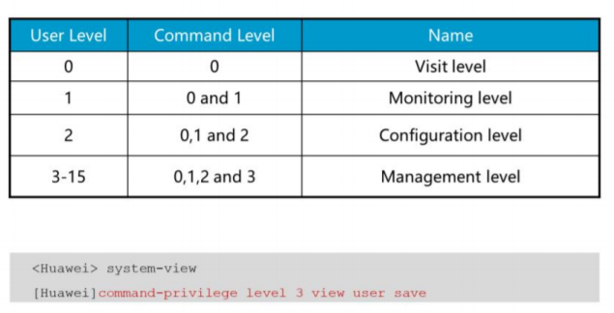

Set the user level on vty0 to level 2

User privilege level 2

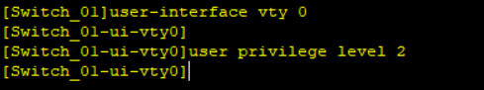

**Set Password for Tele typing devices or local CLI configuration**

Set authentication password cipher

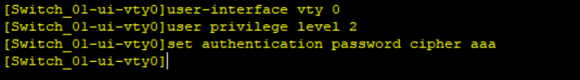

//cipher aaa: Save the password with encryption

//aaa provides user login authentication, means user will have to provide password to login to console. Exp when user configuring the device remotely, he will have to provide login credentials

**ARP protocol works on Link layer.**

As data is encapsulated from top to bottom layers, The IP address at network layer helps to recognize the source and destination Ethernet of received packet, however the destination MAC address must be known to forward the packet, that destination address is provided by ARP protocol. When destination MAC is known, it is easy to reach the destination IP address. The ethernet hop is known at data link layer by ARP before moving to next layer.

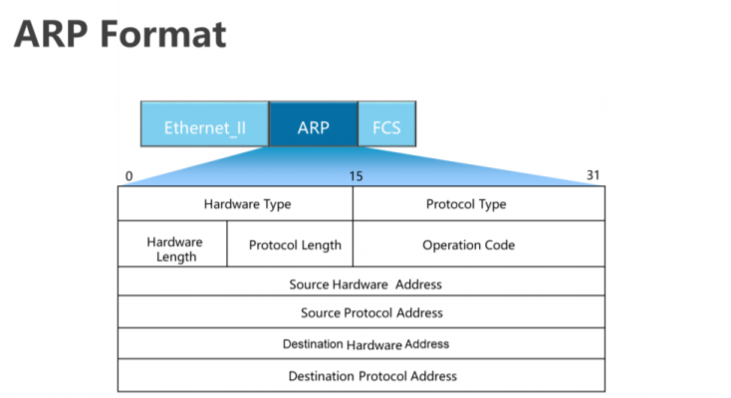

**Connecting 2 networks**

Create 2 networks using 2 Routers.

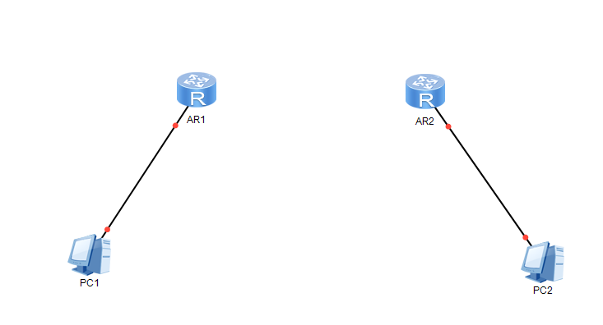

Connect both networks and assign IPS

Router is layer 3 device, so it needs IP address unlike Switch.

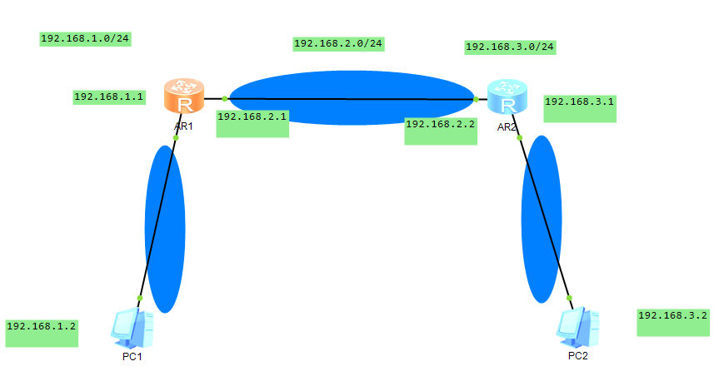

**Now we have designed the network, but have’t configured yet. So now we configure it by assigning IP addresses to PCs and Routers.**

Configure PC1

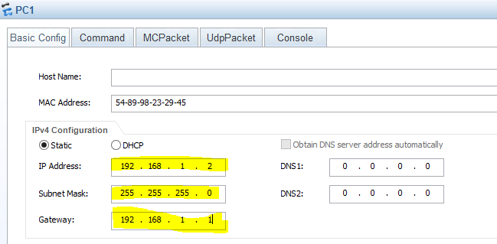

**Configure Router 1 on network 1**

Open Router 1 CLI

Enter into System mode by following command

**System-view**

Give name to your interface

**Sysname Router1**

Assign IP address to Network 1 gateway

**Int g/0/0/0**

**Then**

Ip addr 192.168.1.1 24 //Which is subnet mask

**For router 1 on network 2**

**System-view**

Give name to your interface

**Sysname Router1_Net2**

Assign IP address to Network 2 router port

**Int g/0/0/1**

**Then**

Ip addr 192.168.2.1

**For router 2 on network 2**

**System-view**

Give name to your interface

**Sysname Router2_Net2**

Assign IP address to Network 2 router port

**Int g/0/0/1**

**Then**

Ip addr 192.168.2.2

**For router 2 on network 3**

**System-view**

Give name to your interface

**Sysname Router2_Net3**

Assign IP address to Network 2 router port

**Int g/0/0/0**

**Then**

Ip addr 192.168.3.1

**Then assign to PC2 on network 3**

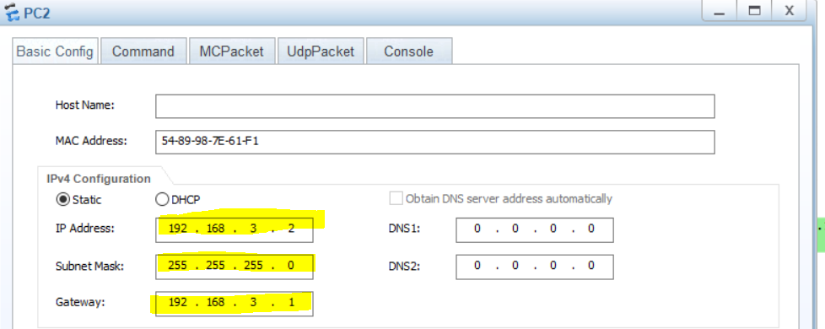

**The End**